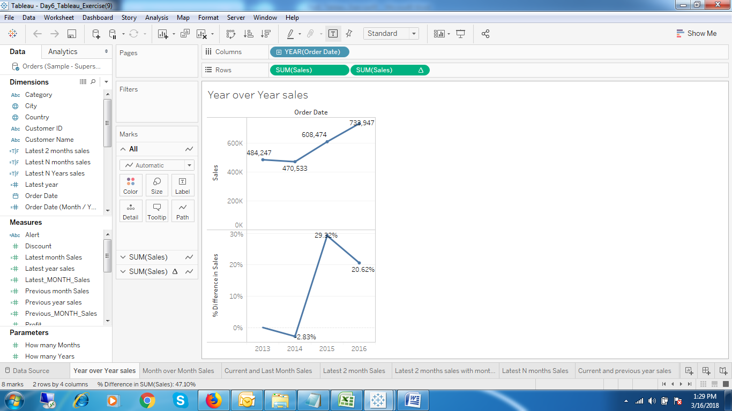

1. Year Over Year Sales

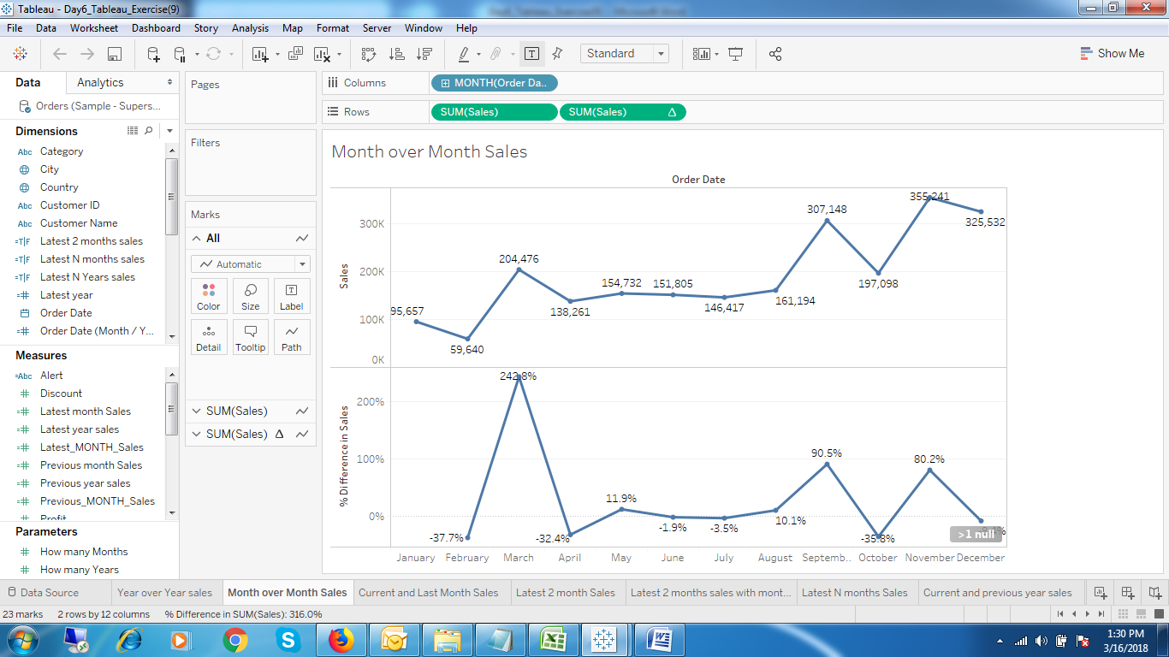

1. Month over Month Sales.

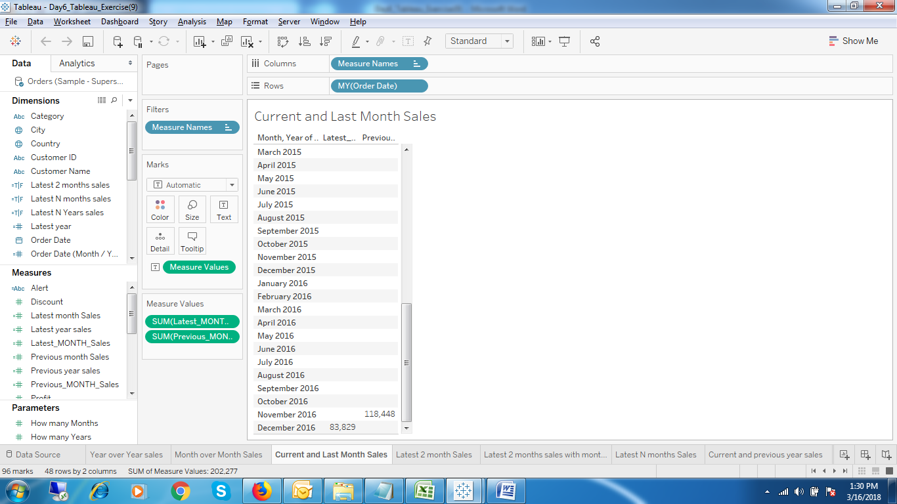

1. Current and Previous Month Sales

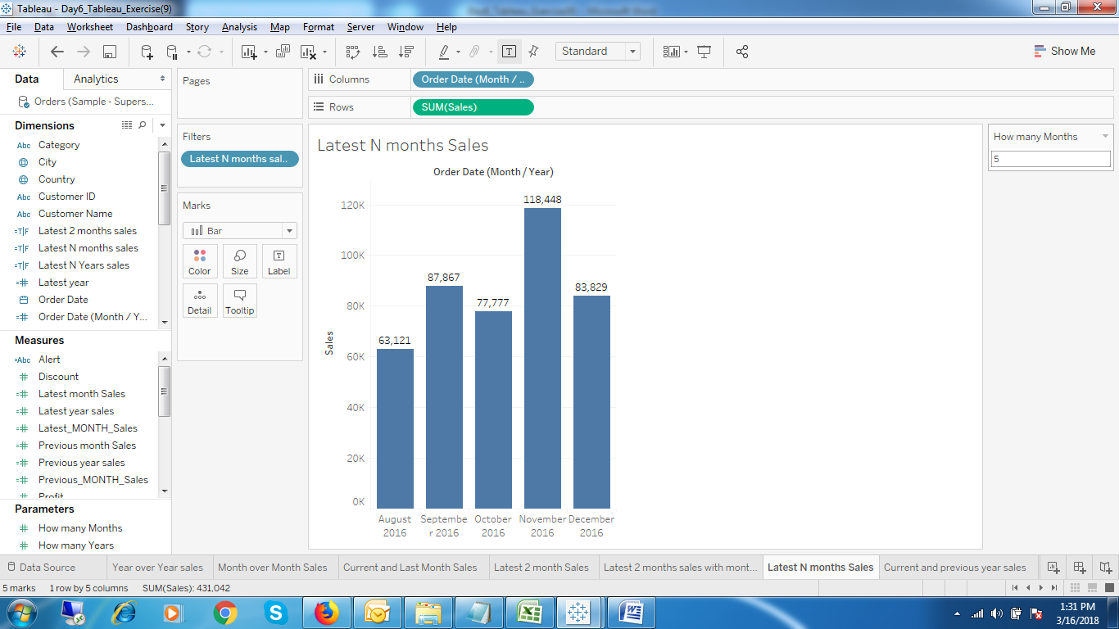

1. Latest N Months Sales

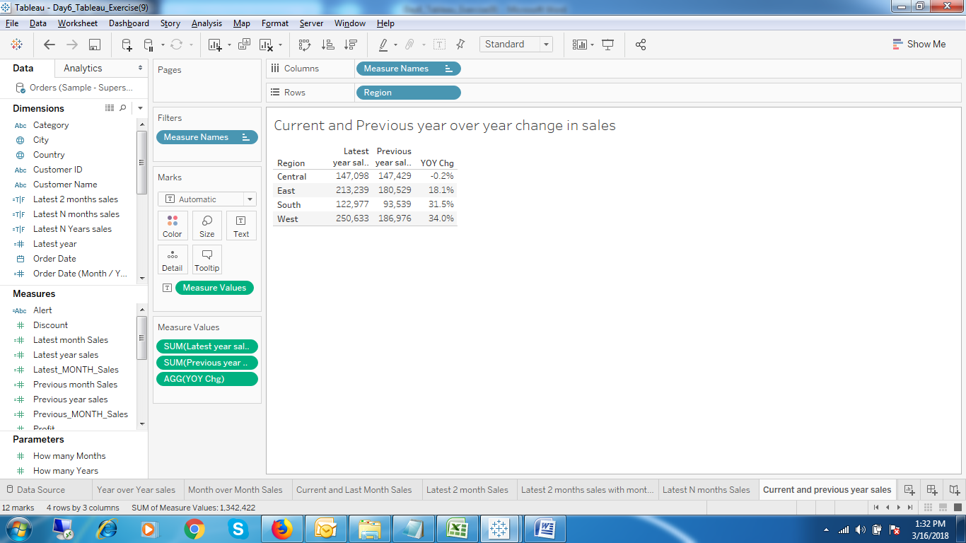

1. Current and Previous Year Over Year Change

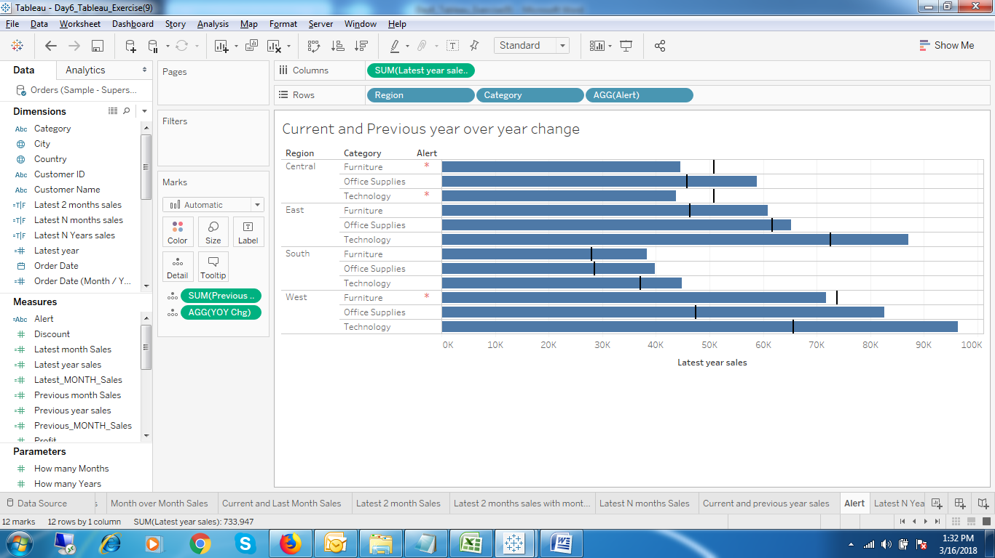

1. Current and Previous Year over Year Change with an Alert.

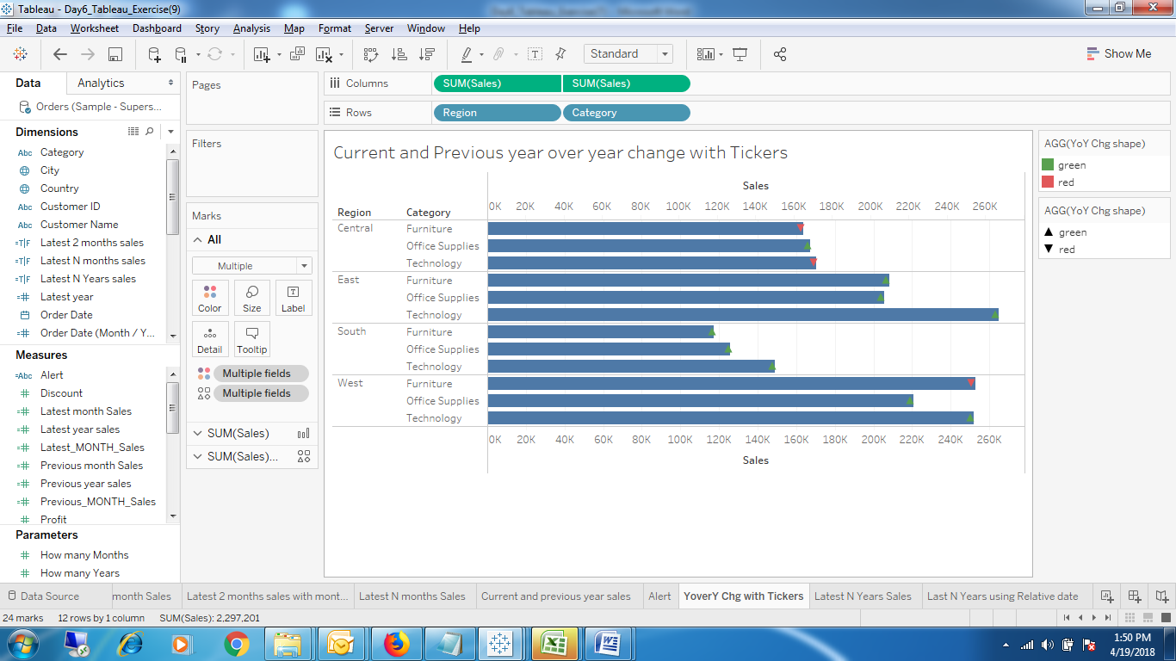

1. Year Over Year chg with Tickers.

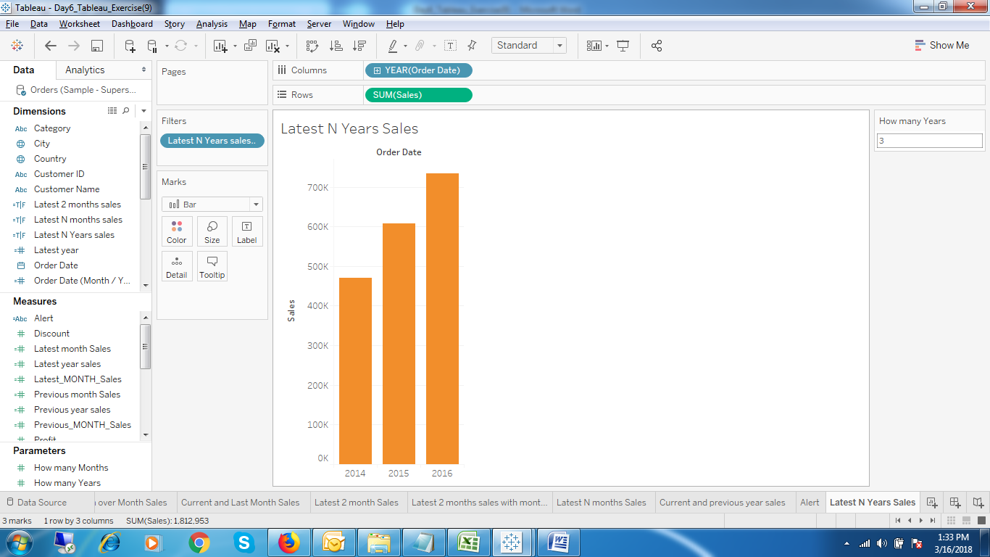

1. Latest N Years Sales

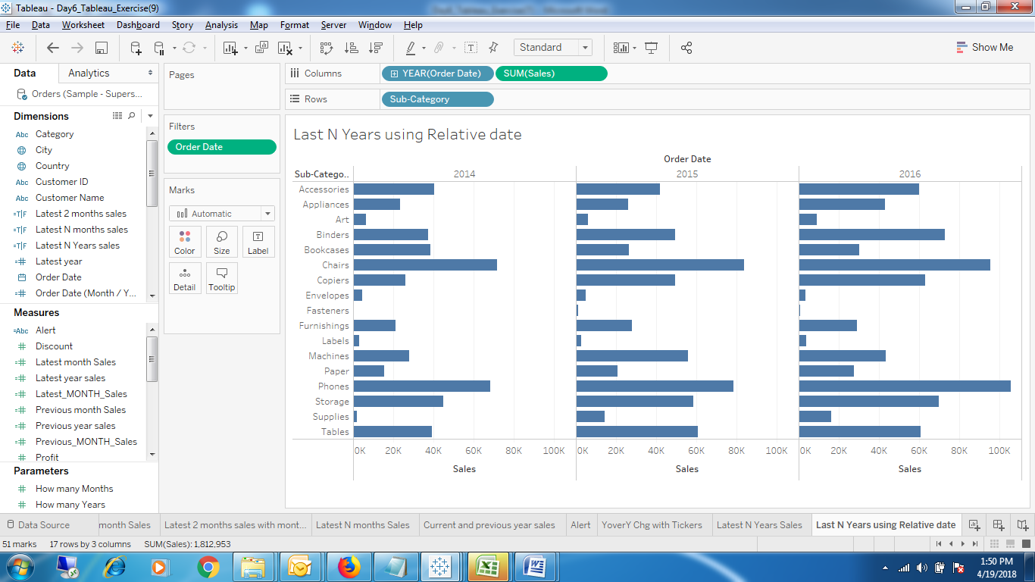

1. Latest N years using relative date.

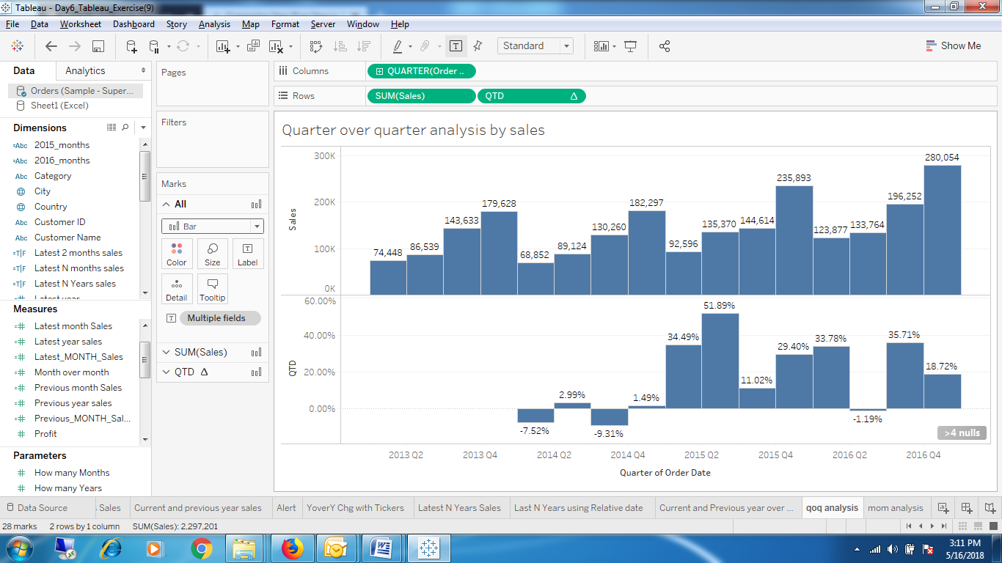

1. Quarter over Quarter analysis by sales.

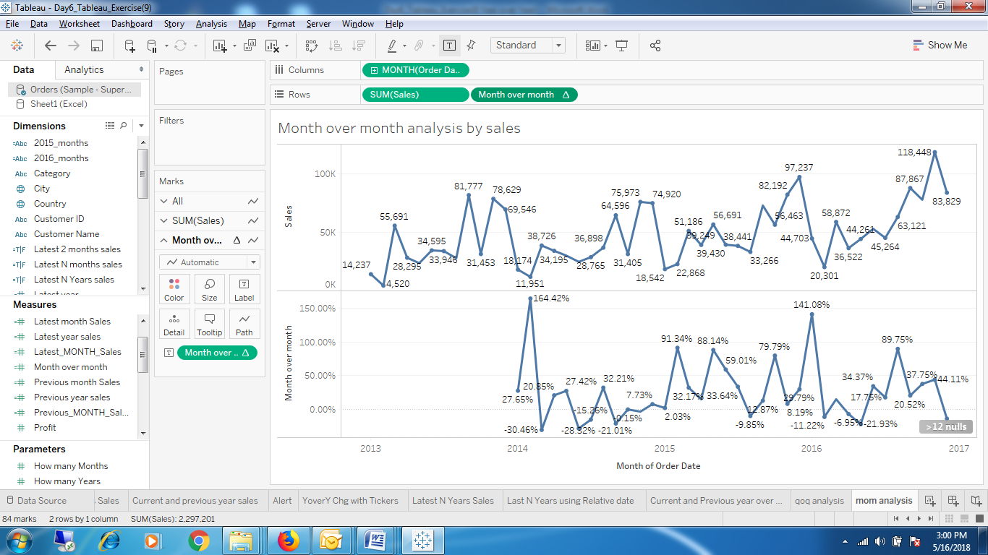

1. Month over month analysis by sales.

Year over year change

(ZN(SUM([Sales])) - LOOKUP(ZN(SUM([Sales])), -1)) / ABS(LOOKUP(ZN(SUM([Sales])), -1))

SUM([Latest year sales])/SUM([Previous year sales])-1 YOY chg